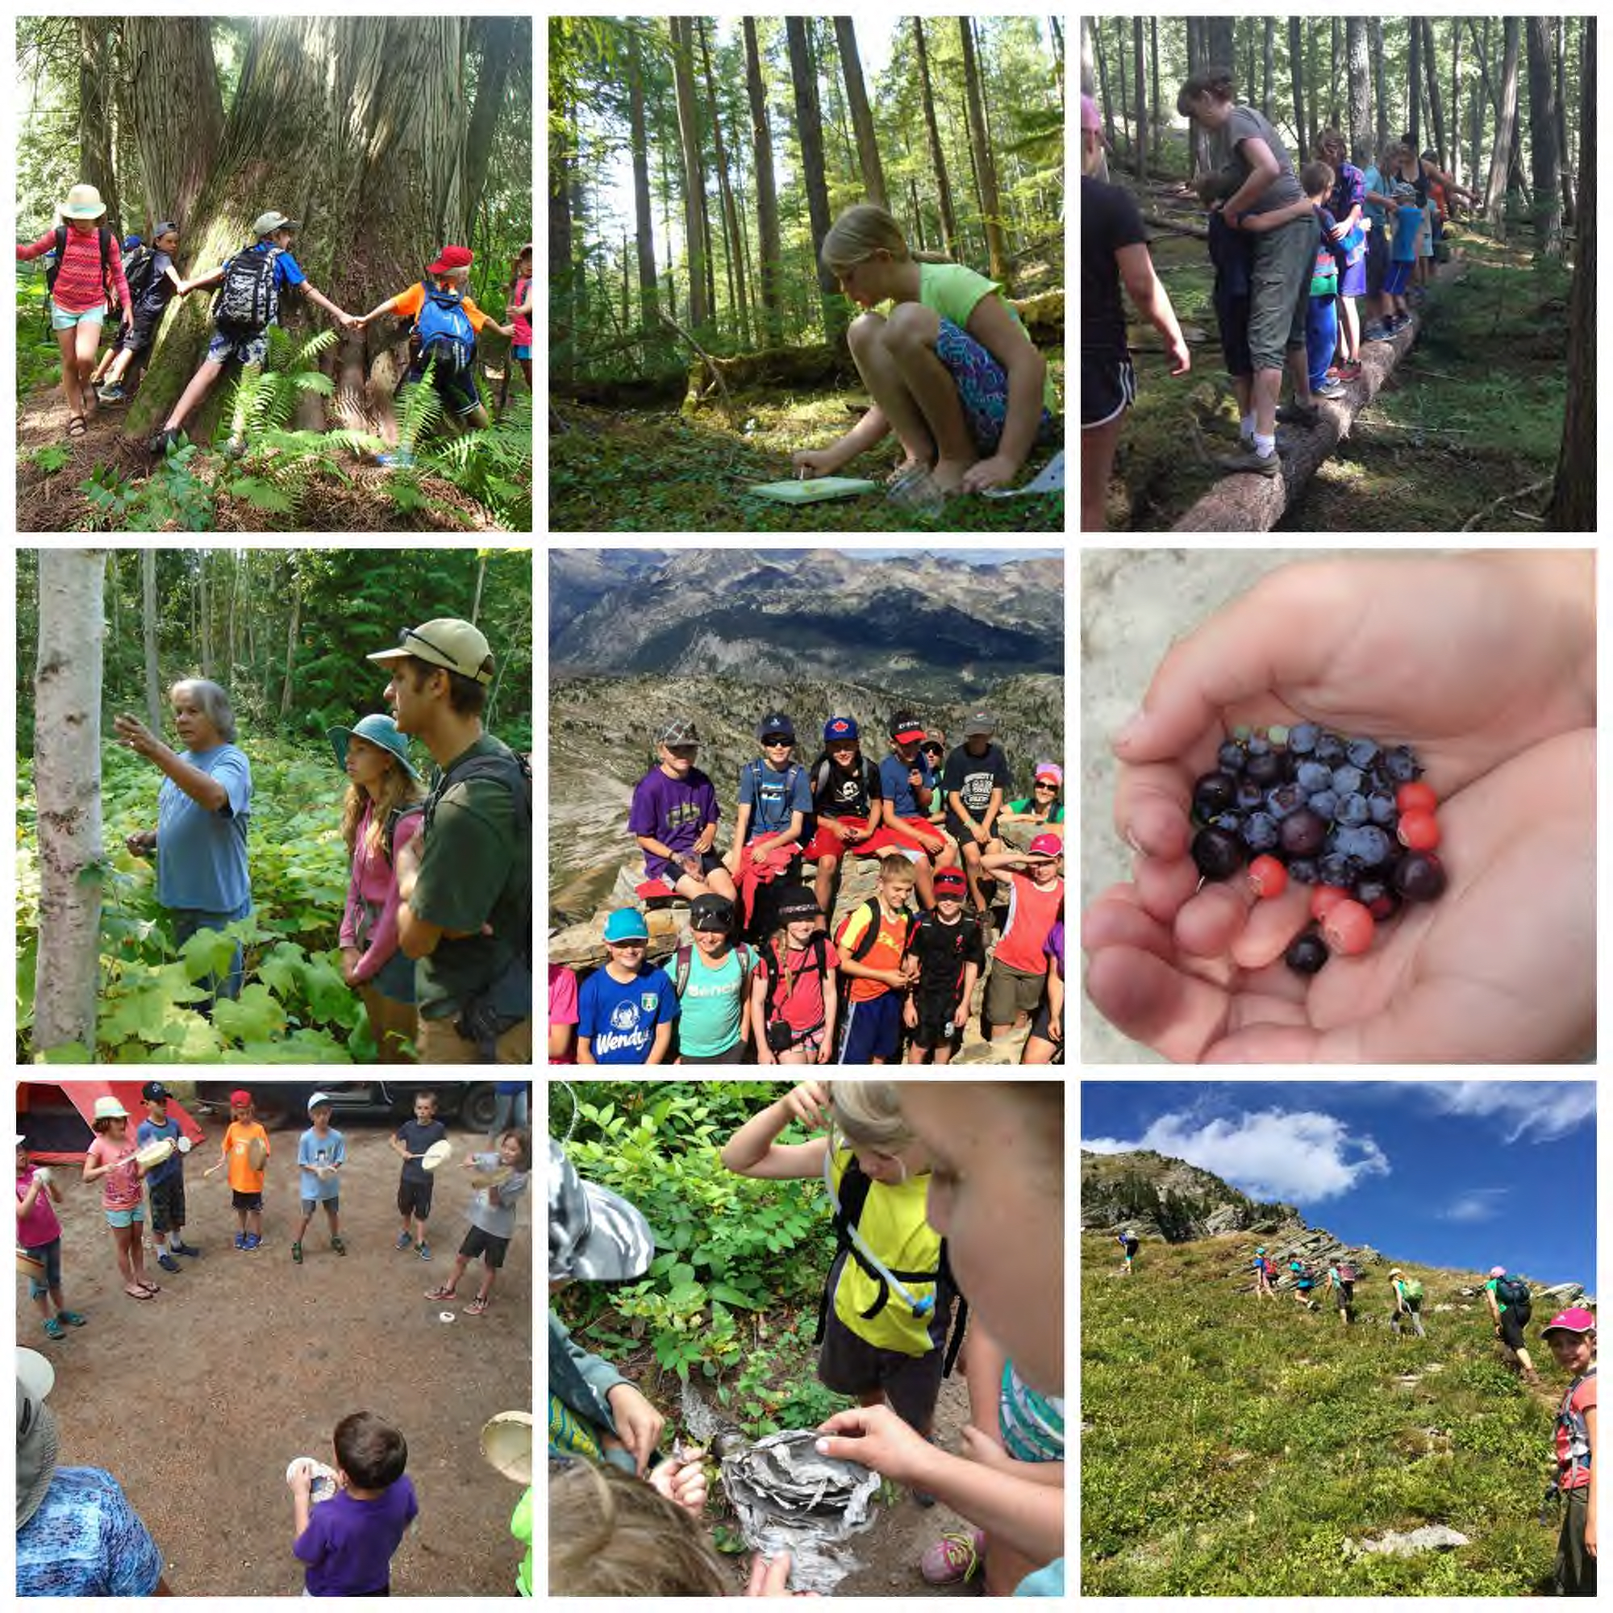  Outdoor Learning in SD 83  - South Canoe  The Vision  Our aim is to develop a school that engages students with local ecosystems. The focus of learning is on inquiry, experience and reflection while teaching the full BC curriculum through nature’s lens.  The Mission Statement  To implement a program that inspires a cultural shift that embraces, protects and connects meaningfully with the natural world.  Philosophy  The three pillars our philosophy is built on.  - Connections to the Outdoors  - Community supported and place-based education  - Experiential Education  Outdoor Learning Vs Outdoor Education  Outdoor Learning- Learning from and with the surrounding natural ecosystems.  Outdoor Education- Adventure driven experiences.  Current Outdoor Learning in SD83  -7 professional development days per year, already offered for over 100 teachers.  -7 ‘Outdoor Awesome’ events featuring whole-school-based outdoor learning stations for 14 elementary schools.  -Many individual educators around the district having their students engage with nature in meaningful ways. | Research  Over 500 peer-reviewed articles exist, exploring a range of topics. These topics include the positive impacts of time spent in nature regarding: ADHD, Autism, executive functioning, academic performance, obesity, myopia, depression, anger, socialization, creativity, critical thinking, resiliency, sleep, improved engagement/behaviour in school, increased focus, impulse control, reduced stress, cooperative play, and irritability, among many others.  Academics  -Boost performance in reading, writing, math, science and social studies.  -Enhances creativity and critical thinking  -Decreases ADHD symptoms.  Well-being  -Increased physical activity.  -Reduces stress, anger and aggression.  -Improves healthy relationships.  A Day at South Canoe  -Balance of academics/outdoor/social-emotional.  -Connections with the community

Agenda for the Evening

Acknowledgements
- Territory
- Committee members · Acknowledge people that have worked on this as part of the Outdoor Learning Committee: (Amanda Bowlby - Carlin, Ceren Caner – Bastion, Chris Stromgren - Jackson, Adam Barraball-Shuswap Middle School, Kira Limbre-Shuswap Middle School, Susan Brown –Armstrong Elementary, Glen Overgaard – North Canoe, Isabelle Gervais - Bastion, and (Irene Laboucane).

Desire for Outdoor Learning in SD83
- 1000 respondents to survey- 522 indicated an interest in enrolling their child.

Background
- Outdoor Learning in other schools and areas.
- Feasibility.
- Possible timeline.
- Intention to register form.

What is Outdoor Education vs. Outdoor Learning?
- What is the difference

What is already happening in our school district.
- How are students and teachers already experiencing outdoor learning

Visits with established Outdoor Learning schools.
-Maple Ridge, Sooke, Sechelt, Williams Lake, Canmore

Philosophy and Practices that fit to the SD83 beliefs
-Place based learning, First peoples Principles of learning, Multi-aged, Inquiry based, Eco literacy Community based, Reading, Numeracy info/data.

What would a day at South Canoe look like for a student?

- Activities
- Balance of academics/outdoor/social-emotional.
- Supporting District wide programs.

Question period

